An Observational Study of Presenters’ Use of Visual Aids for Informing the Design of Presentation Systems
First Author Name (Blank if Blind Review)  Affiliation (Blank if Blind Review)  Address (Blank if Blind Review)  e-mail address (Blank if Blind Review)  Optional phone number (Blank if Blind Review) | Second Author Name (Blank if Blind Review)  Affiliation (Blank if Blind Review)  Address (Blank if Blind Review)  e-mail address (Blank if Blind Review)  Optional phone number (Blank if Blind Review)
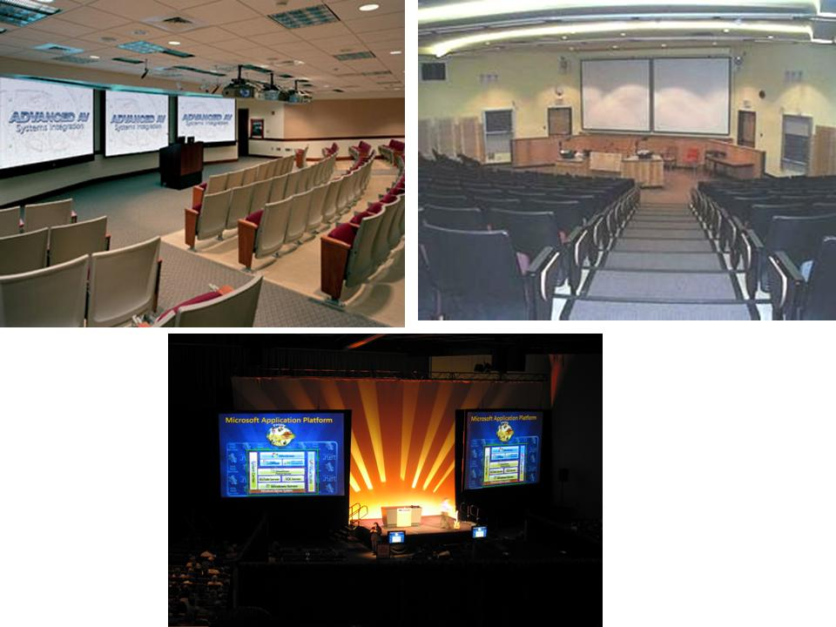Figure 1: Presentation halls and conference room with multiple screens

ABSTRACT

Many lecture halls and conference rooms today are equipped with multiple projectors and large high-resolution displays. Existing presentation software, however, only support a single, static slide projected on one full screen. With the goal of designing richer presentation tools that can take advantage of the increased screen resolution and real-estate, we conducted an observational study that examined current practice with visual aids in presentations. We observed both traditional visual aids such as whiteboards and blackboards as well as presentations using computer generated slides. By observing presentations in both classroom and conference settings we were able to devise several design guidelines for building presentation tools that are aimed at enhancing audience learning. Finally, using these guidelines, we have designed an initial prototype system for authoring and presenting a presentation on multiple displays. .

Author Keywords
Guides, instructions, author’s kit, conference publications.

ACM Classification Keywords
H5.m. Information interfaces and presentation (e.g., HCI): Miscellaneous.

INTRODUCTION
Computer generated slides are ubiquitous. It is almost inconceivable today for a salesperson or a presenter at a conference to appear without a ready-made slide deck. In business settings, conferences and many classrooms, presenters use computer generated slide as the main visual aid to support their talks. To create these slide decks, presentation tools like Microsoft's PowerPoint [ref] or Apple's Keynote [ref] are used. While these tools enable the presenter to easily build sophisticated presentations that use animation and other multimedia capabilities, many critics claim that they are speaker-oriented and not content- or audience-oriented. With computer generated slides, presenters are forced to use a rapid, thin, sequential information style, which is primarily targeted for business presentations and is not suited for contexts where non-linear explanations and complex reasoning is needed [tufte, parker, Kjeldsen].
Current presentation software is tied to a paradigm of a single, static slide projected onto one full screen, changing sequentially over time. Yet, with the increasing resolution of large displays, the increasing power of computers that allow easy window management and window animation, and the decreasing price of projectors, there is no need to stick with this paradigm. Many lecture halls and meeting rooms today, as can be seen in Figure 1, are equipped with two or more projectors, and future lecture halls will likely have high-resolution, wall-size displays. Yet, current presentation software does not support the use of multiple projectors, beyond the common practice of displaying the same slide on many projectors at once.
To address these issues, we have conducted an observational study to examine current practice with both computer generated slides and more traditional visual aids, comparing presentations in both conference and classroom settings. The goal was to identify problems with existing presentation software and to understand how best to utilize multiple and high-resolution screens to support both presenter and viewer. In contrast to computer generated slides, instructors have been using blackboards and whiteboards in classrooms for over two centuries to present and explain complex ideas. A board allows instructors to visually present ideas using a large surface that they dynamically control. Instructors can decide what information to erase and what to keep persistent for future reference. Multiple or sliding boards allow for an even greater amount of information to remain persistent
By examining how instructors use boards as a visual aid for presentations and comparing that with the usage of computer slides, we get a better understanding of instructors' work practices using visual aids. Some of our findings include the need to keep data persist longer, a distinction between different types and roles of content used, and the importance of temporal buildup of complex data. Using our finding, we devise design guidelines for the development of electronic presentation tools. Finally, using these guidelines, we designed a prototype system that enables presenters to compose and present a computer generated slide presentation using multiple displays.

Previous Work

Computer Generated Slides
The most prominent presentation tool is PowerPoint [PP], which has been said to create about 95% of presentations world-wide [Parker]. Along with its prevalence, PowerPoint has generated much criticism. As the most widely adopted tool, PowerPoint has drawn the vast majority of critical attention, but similar critiques can be applied to almost all other presentation tools, such as Apple's Keynote or OpenOffice's Impress.
Perhaps the most prominent criticism is that of Tufte, who claims that PowerPoint degrades communication by forcing users to separate content and analysis, reduces concepts to meaningless bullets, and enforces strict hierarchies that are not needed [tufte]. He further claims that PowerPoint slides have low resolution of data and generate much "Phluff" which confuses the viewers. Others criticize PowerPoint for creating fragmentation of thoughts, and editing ideas by dictating how information should look and be organized [parker, Kjeldsen]. Others answering these critics say that PowerPoint is only a tool which is sometimes used poorly by its users [Norman].

Presentation Systems
Various researchers have developed presentation tools to address some of the issues with PowerPoint and other commercial tools. Some systems concentrated on finding alternatives for the linear style of slide presentations using mindmaps [Holman] or zoomable user interfaces [Good]. Others added support for delivering the presentation, using physical index cards that are digitally linked to slides [Nelson], or handheld devices [myers]. Focusing on classrooms, Classroom Presenter [Anderson] added writings to prepared slides by integrating PowerPoint slides with pen-based writings on a tablet PC. E-Chalk [friedland] was designed to allow instructors using electronic whiteboards to combine the ability to record whiteboard activities with multimedia items and pen-based writings in classrooms. Focusing on the audience, Livenotes [kam] affords cooperative note-taking of students on top of the instructors’ slides. There have been projects [Röüling, Chiu] that have provided some support for multiple projectors; however these projects were limited to showing previous slides on different projectors, each slide filling a whole screen, and required sophisticated infrastructure.

Presentations in Education
PowerPoint is widely used in higher education, mainly as a presentation tool showing ready-made slides. Although it is prevalent in the classroom, the pedagogical implications of using computer generated slides remain unclear. Most studies focusing on whether or not computer generated slides are beneficial have found that students responded positively to the use of computer-generated slides in the classroom in comparison to whiteboards and overhead transparencies [Szabo, Levasseur, Daniels].] Students have indicated that slides help them improve organization of the course, help them learn course material more effectively, and make classes more interesting and entertaining [Levasseur].] In many classes, instructors are expected to use presentation software, and those who do not use slides are looked at as unprofessional. However, most studies examining the effect computer-generated slides have on learning outcomes have found no significant improvement in student performance with slides compared to other visual aids [Levasseur, Szabo].
Theories of cognitive and educational psychology acknowledge the advantage of using visual aids to assist learning. Meyer [refs] theorized that we process information through two separate channels: visual and auditory, and that learning can be enhanced by using both channels together. The working memory will organize and connect the two channels and unite them into the long-term memory. According to this theory, these channels are limited in their processing abilities and since learning requires much activity in these two channels we risk cognitive overload if we overwhelm both channels.

Electronic Whiteboards
Initial whiteboard projects have mainly been found in the Computer Supportive Cooperative Work (CSCW) community, which considers the whiteboard a shared co-located collaborative tool for meetings. Several researchers have investigated how to organize and arrange materials on the board, the types of collaborative activities that could be supported by electronic boards, and and how could electronic whiteboards support these activities [Rekimoto, Mynatt, Pederson]. Other researchers have focused more on classrooms. Two surveys of the literature on the effect of interactive whiteboards on class [Smith, Glover] include mostly small-scale studies on the impact of interactive whiteboards on pedagogy and on the classrooms. They report positive feedback from both students and teachers. Teachers reported having more flexibility and versatility in their classes. Students were reported to be more motivated because of the high level of interaction the electronic whiteboard enable.

Methodology
To understand presenters' use of visual aids, we first observed general visual aid use in classrooms at our university campus. From this initial period of observation, we developed a coding scheme for presentations, which we then applied in a larger, structured observational study of both classroom and conference presentations.

Initial Observations
Before designing the observational study we attended 60 hours of undergraduate classroom lectures. The goal was to develop a general understanding of how instructors use visual aids in the classroom and, from this, to devise categories of usage that could be used to build the coding scheme for the larger study. The lectures were from many different instructors on a variety of subjects, ranging from mathematics and chemistry, to political science and psychology. We purposely attended lectures in classrooms of various sizes and with different visual aids, including whiteboards, blackboards, overhead transparencies computer slides and combinations of these. In these lectures, we did not record detailed interactions or board content, but instead wrote general observations concerning the use of visual aids. Further details can be found at [Lanir].
We identified four distinct types of usage for whiteboards and blackboards in classrooms: logical progression, sentence, immediate aid, and main focus. Examples of these can be seen in Figure 2.
Logical Progression (LP) style of usage is common in science, engineering and mathematical classes. Usually the instructor is solving an equation or problem by writing one line beneath the other. Each line is derived from the previous line (sometimes from more than one line) until a conclusion is reached. An example is an instructor writing a proof for a mathematical statement. Often, Logical Progression is accompanied by a diagram or other annotations to illustrate an aspect of the problem.
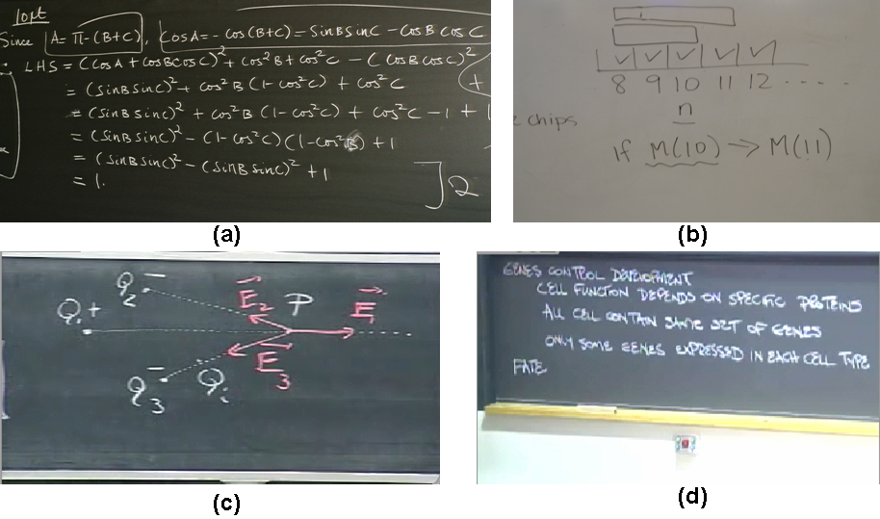
Figure 2. Examples of different types of board usage: (a) Logical progression, (b) Immediate aid, (c) Main focus, (d) Sentence.

Immediate Aid (IA) is as a “just-in-time” visual aid for the instructor. It only persists in the context of explaining something specific. It is characterized by the fact that it loses meaning without the context of the instructor’s speech: looking at the board afterward usually will not have much meaning for the observer. The board may contain a collection of disconnected sketches, equations, numbers or words. The purpose of this content is as an anchor, a tangible object for the instructor to have concurrent with his or her words. For example, a math instructor might say: “take for example a circle” and then draw a circle on the board. The instructor will usually write this on any open place of the board, not necessarily in any order or on a specific board.
Sentence occurs when the instructor writes text on the board to emphasize an important point, to provide a heading for a topic about to be discussed, to write down a bullet-point list, or just to spell out a word.
Main Focus occurs when the instructor uses the board as the main focus of the lecture, by using a diagram, table or graph. For example, in a physics class the instructor may wish to explain the concept of an electric field by drawing some particles and many arrows representing the electrical field. During the explanation, the instructor will gesture at the diagram many times, often adding temporal layers to the diagram, sometimes using colors as can be seen in Figure 2c.
For instructors using computer generated slides, we also categorized content of slides in a similar way. Slides can contain text (Sentence), logical set of equations (LP), or a diagram, graph or table (Main Focus). Slides may also include images (e.g., photographs), but do not include IA. IA requires the presenter to dynamically change the visual content, which is easily done with a board and chalk or marker, but not with preset slides.

Structured Observations
Based on our initial observations and categories of usage, we developed a coding scheme for a larger observational study, in which we coded usage of visual aids during presentations from three different corpora: (1) conference presentations using computer generated slides, (2) university lectures in which the majority of the lecture was given using computer generated slides, and (3) online lectures in which the majority of the lecture was given using a blackboard or a whiteboard. We chose these corpora so we will be able to compare the usage of computer generated slides in two different settings (conference and classrooms), and we will be able to compare the usage of slides with the usage of another visual aid that is more dynamic and uses more screen real-estate (classroom lectures using slides vs. classroom lectures using boards).
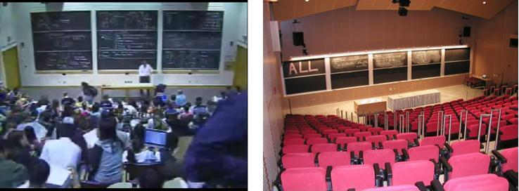
Figure 2.5. Examples of classrooms with sliding boards

Conference Slide Presentations
We examined 21 presentations at the ED-Media conference in June 2007. These were scientific presentations of research contributions to the field of educational multimedia. All presentations were held in small rooms (up to 50 seats) using a standard projector and a standing screen with an approximate size of 1.5m x 1.5m. The screen was situated at the front of the room with the top of the screen at a height of approximately 2.5 meters in such a way that it was easy and natural for the presenter to gesture at a slide if he or she wished so. The average presentation time was 17.8 minutes (SD = 4.4). Thirteen of the presenters were female and eight were male.

Classroom Slide Lectures
To see if presentation style and use of slides differ between a formal conference presentation and classroom lectures using slides, we examined 18 undergraduate lectures given at our university in which the main visual aid was computer generated slides. Classes were from different areas including psychology, economics, chemistry, biology, political science, anatomy and nutrition. All classes were held in large lecture halls (more than 150 seats) equipped with projectors. The size and location of the screens varied according to the lecture hall, yet most screens were positioned high above the presenter's reach. In order to gesture at specific areas of the screen, some instructors used a laser pointer or the laptop's mouse as a pointing object. Others did not use any gesturing device. Average lecture time was 48.0 minutes (SD = 8.7). In the 18 lectures, there were 12 different instructors, 7 female and 5 male.

Classroom Whiteboard Lectures
We coded 15 lectures offered on MIT Open Courseware [1] by 15 different instructors (2 female and 13 male). All lectures used blackboard or whiteboard as the main visual aid. The videos were professionally made and were recordings of MIT undergraduate classes. Most lectures (13) were in large lecture halls using a 3x3, 3x2 or 5x2 grid of sliding boards (see Figure 2.5). The remaining three lectures were in small classes and used only two horizontal boards. Class subjects varied and included biology, chemistry, electrical engineering, computer science, material science, mathematics and physics. Average lecture time was 44.8 minutes (SD = 6.0).
We used online lectures, since we found from our initial observations that there was much more interaction during board-aided lectures. As opposed to the slide lectures in which coding was fairly simple, the annotation in the board lectures was much more difficult. Coding videos of the lectures allowed us to pause and recheck our annotations. Even using the videos, we continued to refine the coding scheme for the first few lectures, so we recoded each video twice to ensure the consistency of our coding.

Coding Schemes
We developed two coding schemes, one for the whiteboard/blackboard lectures and one for the slide lectures and presentations.
Slide coding scheme. For both the conference and the slide lecture corpora we used the same coding scheme, recording the time for each event. The major events were:
- New slide: A new slide appears. Slides were further categorized based on their most prominent type of content: text, diagram, graph, image, or table.
- Layer. New information is added to a slide.
- Slide back. The instructor returns to a previous slide.
- Gesture. Both hand gestures and gestures using an aid, such as a laser pointer or the computer’s mouse, were counted as gesture events. They were further categorized as either single, a single gesture at a slide or continuous, multiple gestures at one slide.
Whiteboard/blackboard coding scheme. For this coding scheme, each event happens on a single board unit. We define a board unit as a part of the board that the instructor uses as one logical area. When using sliding boards, often a board unit is one physical board. Yet, the instructor may draw a line to divide a physical board into two or more units when the board is too wide or when he or she wishes to define separate logical units. We recorded the location and time of the following major events:
- Writing. A single writing event was determined according to the content. For example, drawing a diagram was coded as one event, writing a sentence was coded as one event. Writing events were categorized into groups according to our initial observations: sentence, logical progression, immediate aid and main focus. Main focus was subcategorized into graph, diagram, and table.
- Layer. New information added to content written earlier.
- Erase. Entire board or item of content erased.
- Gesture. Gestures at the board were also recorded and categorized as continuous or single.

Coding Reliability
All coding was done by a single researcher (the first author). However, to assess the reliability of the coding scheme, a second coder also attended two of the lectures from the classroom slide corpus and coded two randomly chosen lectures from the online lectures corpus. For the slide lecture corpus, there was a 94% match on events between two coders (Kappa coefficient = 0.89) missing only a couple of gesture events. There was also a 99% match on the content of a presented slide. (Kappa = 98%). In the Online lectures corpus, there was an 86.7% match on events (Kappa = 0.79). We encountered some difficulties assessing the content reliability. When coding the first online lecture, the second coder forgot about the immediate aid (IA) category and coded these events as belonging to the Sentence category. When coding the second lecture only 4 out of the 7 IA events were recorded by the both coders. These actions suggest that there may be some problems in the distinction of the IA category. Grouping the three missed IA events from the first lecture to the Sentence group yielded a 91.5% match on content (Kappa = 0.87) between the two coders. Stating them as errors yielded a 84.1% match (Kappa = 0.80).

Interviews
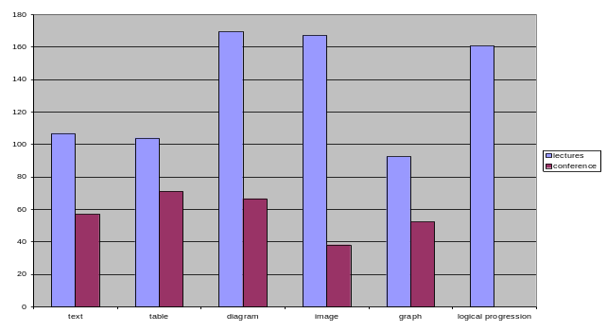
Figure 3. Average time spent on a slide for each type of data content for conference and classroom slide corpora.

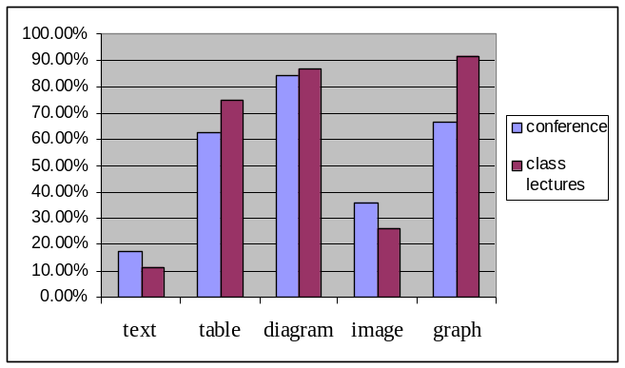
Figure 5. Percentage of slides gestured at for each content type for conference and class lecture corpora.

To supplement the observational results, we also conducted semi-structured interviews with five experienced university instructors from computer science, mathematics and commerce. Interviews were designed to fit in a one hour session. Instructors were asked about the kinds of visual aids they used in their classrooms, when they used each medium, why they used each medium, what medium they preferred in which circumstances, how they usually used the board and the slides and so on. While all participants were asked the same questions, we encouraged instructors to elaborate and digress on what they felt was important. Interviews were conducted by the same researcher, recorded and then analyzed.

Findings
We report on quantitative and qualitative findings from our observations of the three corpora. Because they both use computer generated slides as the main visual aid and use the same coding scheme, we first report on the findings from the conference and the classroom slide lectures together. We then report on the classroom whiteboard lecture corpus.

Computer generated slides

Content
Computer generated slides were used as the main visual aid in both the conference and the classroom lectures corpora. Figure 3 shows the average time spent on a slide for each type of data slide for both corpora. The average time spent on a slide was significantly less in the conference corpus (54.5 seconds) than the classroom corpus (112 seconds) (t(806) = 35.2, p < 0.001). This difference complied with our expectations since the conference presentations are shorter and usually try to convey more information in the short time allotted to each presentation, while the class lectures are longer and concepts are explained in more detail, spending more time on each slide. Within the classroom corpus the time spent on diagrams, images and logical progression slides (combined average M = 162.1 s, SD = 174.2) was longer than time spent on text (M = 106.1 s, SD = 84.2) and table (M = 96.7 s, SD = 30.5) slides. Within the conference corpus, we see that time spent on diagrams (M = 66.5 s, SD = 45.3) and tables (M = 71.1 s, SD = 56.4) was longest. Because of the high standard deviation of all categories there were no significant differences between the categories.
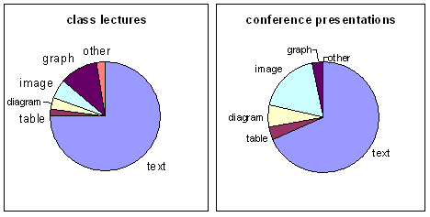
Figure 4. Proportion of each content type for conference and classroom slide corpora.

The distributions of the different slide groups (text, diagram, graph, image, and table) in both corpora using computer generated slides are shown in Figure 4. As we can see from the figure, in both corpora, text was the main visual component of the slideshows (68% of slides in the conference corpus were text slides and 75% in the class lectures).

Gestures
Gestures at slides are usually done when the instructor connects the spoken word to the visual aid, focuses the attention of the audience on the visual aid, or specifically shows some detail on the visual. As can be seen in Figure 5, in both corpora using computer slides, there was a dramatic difference between the percentage of gestures on text slides and on other types of slides. Text slides were least gestured at (17% of text slides were gestured at in the conference corpus, and 11% in the classroom corpus). Diagrams, graphs and tables on the other hand, were highly gestured at (combined to 73% in the conference and 88% in the classrooms). Moreover, out of the text slides gestured at, 41.3% of the conference and only 8.6% of the classroom corpus were continuous gestures, while 84% and 43% of the diagrams, graphs and tables gestured at (combined) were continuous in the conference and in the classroom corpora respectively.
This can be explained by the fact that text is usually self explanatory and is in the same modality (verbal) as the spoken explanations. Therefore, the presenter may not need to connect the spoken words with the visual aids using gestures. Diagrams, graphs, and tables, on the other hand, are pictorial data that present detailed information. The verbal information that is conveyed by the presenter about them needs to be shown in the context of the visuals.
What surprised us about these results was the relative compliance between both corpora. Although both corpora were very different in the setting, type and content of the presentation, and shown significant differences in time per slide, both the distribution of types of slides, and the amount of gesturing on each type of slide (Figures 4 and 5) show quite similar trends.

Blackboard / Whiteboard usage
We report on the findings from the whiteboard lecture corpus separately since the coding and interaction in these lectures were very different than those in the other two corpora.

Content
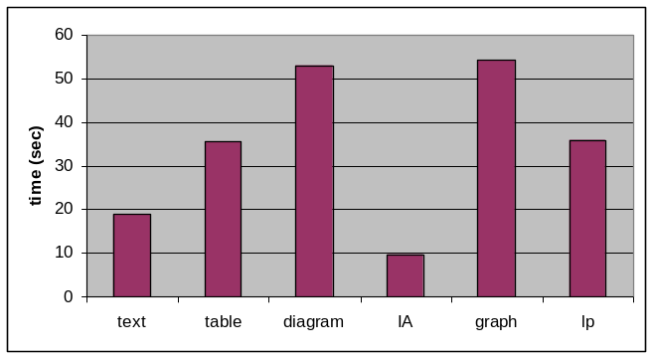
Figure 6. Time spent on writing events for each content type for the whiteboard corpus.

Figure 6 shows the amount of time instructors spent writing each type of data. This was measured from the beginning to end of writing the content, and may include pauses for explanation in which the instructor did not write. We conducted a one-way ANOVA to evaluate the effect of content type on time. A main effect of content type was significant (F(1,5) = 16.4, p < .001). The pairwise comparisons, using a Bonferroni adjustment, showed that text (M = 18.9s) was significantly shorter to write than diagrams (M = 53s), graphs (M = 54s) and LP (M = 36.1), (p < .001 for all comparisons). IA (M = 9.8s) type of content was also significantly shorter to write than diagrams, graphs, and LP (p < .001). LP was significantly shorter then diagram (p < .010).
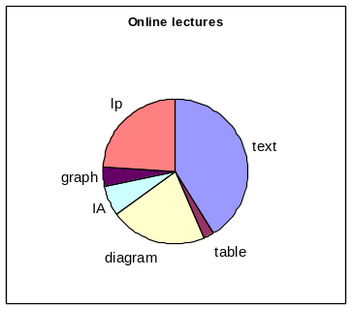
Figure 7. Distribution of content types for writing events in the whiteboard corpus.

These results help us distinguish between two different group types. The rich content group includes the main focus type (diagram, table, graph) and the logical progression types. The support content group includes text and immediate aid types of content. Rich content is focused on much more by the instructor. It is gestured at more often (see Figure 8), takes more time to be written (as can be seen in Figure 6), and has fewer iterations (see Table 1). Support content, in contrast, takes less time to write, and is gestured at and iterated upon less. This group distinction, excluding the IA type which does not exist in slides, is also applicable to the slide corpora. The slide corpora also show more gesturing on rich content (Figure 5), and slightly more time spent on rich content (Figure 3). Image type can be added to the support group as it shows fewer gestures than graphs, tables of diagrams.
Figure 7 shows the distribution of the different content types that were written on the board. Comparing this distribution to the slide corpora (Figure 4) we can see that the different types are more evenly distributed, and that there is less text content using the whiteboard and more diagrams and logical progression content. While this can be partly attributed to the types of classes using the boards (more scientific), it may also be caused by the fact that writing of text takes time and if the text is not prepared in advance, it is not "worth" spending the time to write it on the board.
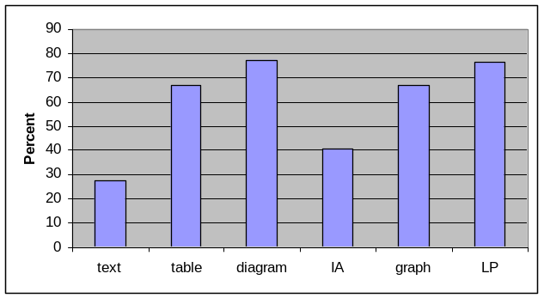
Figure 8. Percentage of writing events gestured at for each content category in the whiteboard corpus.

Gestures
Gestures are more natural when the instructor stands near the board as there is an embodiment of the instructor with the visual aid. Figure 8 shows the percentage of events gestured at for each type of content. This distribution seems to follow the trend shown using the slides of high percentage of gestures on rich content (combined 75.2%), and a lower percentage on text (27.6%) and IA (40.6%).
During the writing of a content event, many times the instructor would lift the pen or chalk, explain the content with gesturing, then continue writing the same content. We recorded this as one writing event, but we also recorded the number of writing iterations, distinguishing between two iterations as having a gesture between them. The average number of iterations and frequency of iterations can be seen in Table 1. We can see that for the rich content types, especially graphs and diagrams, a high percentage of events is iterated upon.
In a whiteboard/blackboard setting, the instructor is usually close to the board, making it easier to gesture at the desired content, so we had expected that there would be more gestures in this corpus than in the slide corpora. To compare the number of gestures using the whiteboard and computer slides, we compared between the two classroom corpora. There was a significant difference showing more gestures in whiteboard classes (M = 38.2) than in slide classes (M = 6.5) (t(28) = 16.4, p < 0.001), even though the lecture lengths were similar between the two corpora. This may be a bit misleading since we recorded each gesture as being either a single gesture or a continuous gesture. A continuous gesture may incorporate many single gestures. However, the whiteboard classes also had more continuous gestures (56.0% of the gestures were continuous) than the slide corpus (25.8% of the gestures were continuous).
 | D | G | LP | Table | IA | Text
Average iterations | 3.4 | 4.6 | 3.3 | 3.6 | 2 | 3
% of events iterated upon | 41.1 | 42.8 | 32.4 | 25 | 3.1 | 0.5

Table 1. Average number of iterations and percentage of events iterated on for each type of content for the whiteboard corpus. (D = Diagram, G = Graph)

Erasing Data
An erase event was defined as erasing a whole board or a whole writing event after it has been written. It does not include the immediate erasing of writing errors. Ten out of 13 lectures using sliding boards did not erase a single board, keeping all data written on the board available to the audience throughout the lecture. Three out of the five instructors who erased a whole board (because of lack of space) erased the oldest content on the board, while two instructors skipped certain boards from this "round robin" treatment, because they wanted the data on the skipped board to be kept persistent. This is shown by the fact that they later gestured on the skipped boards. Single writing events were rarely erased. This happened only four times by three instructors, but it is interesting to note that out of these four times, three events were of IA type and one event was of text type.

Data persistency
Using the board, data persists longer than when using slides, allowing the audience to see previous content. Using sliding boards, content often persists on the board throughout the entire lecture, while using regular boards, the instructor controls which content will persist and for how long, by deciding what to erase and what to keep on the board. To examine if data not only persists longer, but is also used later by the presenter or audience, we studied gesture and layer events on older board units.
To illustrate the degree to which instructors refer back to previous content in whiteboard/blackboard lectures, Figure 9 shows one whiteboard lecture using sliding boards throughout time. The X axis represents time, while the Y axis represents board units. Each box represents a writing event in time (X) and space (board in Y). Arrows represent gestures at the corresponding content, and the green lines represent the addition of layers on top of existing content (e.g., adding new content to a previously sketched graph). Using this diagram, we can try to understand the flow of the lecture's use of the whiteboard.
The active board is the board where the most recent writing event occurred. A referral back is defined as a gesture to a previously written content item on a board unit other then the active board. Often, when instructors verbally refer back to a concept which they have already illustrated on the board, they will gesture at the visual aid (item of content) that was used when explaining this concept. This helps the students to easily recall the previous item and reduce their cognitive load when they learn new items, since they connect the concept with the place and image of the visual aid. An example of this can be seen in Figure 9A. There was a total of 117 referral backs for an average of 7.8 per lecture (SD = 4.4). The average elapsed time between a writing event and a referral back to that content was 8:55 minutes (SD = 403 sec). If we try to compare referral backs with computer slides, the only similar behavior is the presenter going back in the slide presentation to show a previous slide. Presenters went back to previous slides in their deck only six times total in the classroom slide corpus and only three times in the conference corpus.
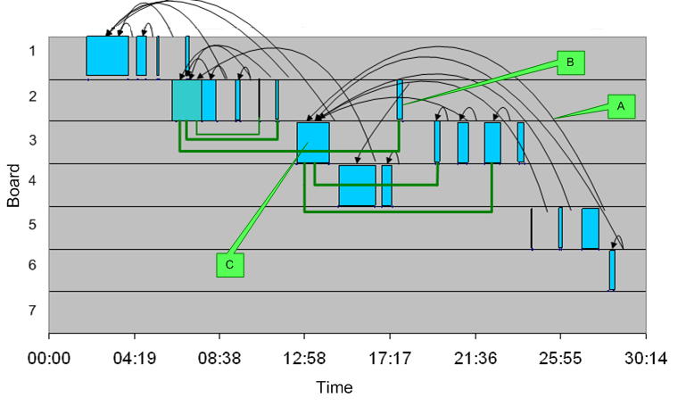
Figure 9: Example of a whiteboard class. Blocks represent writing events, arrows represent gestures, green lines represent layer events.
Referral backs composed of 23.5% of all the gestures, yet 62.3% of the gestures were made at content items that were no more than 3 writing events from where the gesture was made. This shows us that most gestures are still made at the closer vicinity.
A write back is a writing event on a previously used board which is not the active board. This usually occurs when the instructor adds a layer to existing content (like a diagram) or when the instructor writes new content in proximity to previously written content usually because it is semantically related. An example of this happening can be seen in Figure 9B. Instructors averaged 2.0 write backs a lecture (SD = 2.9).

Highly Referenced Content
We observed that in many lectures, there were content items that were the "center of attention" for a long time. The writing event highlighted in Figure 9C, for example, took a minute and a half to write, but then from around minute 20 until minute 30 it was referred back to and written on several times and was clearly still active. In this lecture, it seems that the first three content items on the first three boards were used in this manner, which suggests that these items are the most important ones to keep persistent for longer times.
In order to examine how many of these content events there were per lecture, we defined a highly referenced content item as one which was gestured at or layered back on at least five times from different times in the lecture. Given this definition, there was an average of 1.9 highly referred content events per lecture (SD = 1.2). It is interesting to note that 4 lectures had 0-1 highly referred events, while all but one of the rest had 2-3. All but one highly referred events were of rich content type.

Board usage
Instructors used on average 9.2 board units per lecture (SD = 2.1). We examined the amount of time that each board unit was the focus of attention, that is, from the time the instructor begins writing on a board unit until the time the instructor begins writing on a different board unit (write back times were included for the board time they were written on). The average time that a board unit was used was 5 minutes and 22 seconds (SD = 179 s). Each board unit contained an average of 3.13 (SD = 1.78 s) writing events.
It is difficult to compare between the amount of information written on the boards and the amount of information shown on slides. Our feeling from our observations was that a board unit contains about the same information as one to two slides. To get a very rough estimate, we conservatively translate whiteboard events to slides according to the following transformation: any one diagram graph or table event, two LP events, or three sentence or IA events equals one slide. Using this transformation we see that if whiteboard lectures used slides they would spend 162 seconds per slide. We compare this with the slide lecture corpus in which it took 112 seconds per slide. Using this transformation, one board unit equals 1.8 slides. Although this is a very rough estimate, it coincides with our initial hypothesis. This supports the idea that a slide lecture show more information than the whiteboard lecture. An explanation for that is that data on computer slides is pre-made and there is no need to spend time writing it.

Comparing between two boards
We noticed that in some cases, instructors explicitly compared between two items on a single board or on two different boards. This could be identified by iterating gestures between two content items. We asked instructors if they compared between items when they use the board. <report here on answers and put quote>

Using boards and slides together
In our initial phase of observations, we noticed that it was not uncommon to use two different visual aids in one lecture. There were two main styles in which computer slides and boards were combined. In the first, the main aid was the board and slides were used to show either pre-made, high-resolution material, or images showing important information. The second style was to use slides as the main visual aid, and the board primarily for digressions from the main theme, to answer questions, and for more dynamic type of usage like IA, or sentence headings.

Pacing
The pace of the presentation is different when the presenter uses slides or a board. Using slides, presenters usually follow a steady pace, going from one idea to the next in a linear way. Boards, on the other hand, support more in-depth explorations of a single idea. The temporal build up of a problem has an important role, allowing the audience to gradually understand each building block of the problem. This is shown mainly in rich content like diagrams or LP that usually represent more complex information.
Indeed, diagrams (21%) and LP (24%) type were much more common in the whiteboard corpus than in the slide corpora (4% and 2% respectively) as can be seen when comparing Figure 7 to Figure 4. Looking back at table 1, we see that rich content has more gesture iterations suggesting temporal build up of the information. This can also be seen by looking at the layer event. In the whiteboard corpus there were a total of 47 layer events in which additional information was added onto existing information. Although possible to do in PowerPoint, This type of behavior was not observed in the slide corpora.

Discussion
Table 2 presents the advantages of computer generated slides vs. the advantages of boards summarized from our observations and interviews. When designing electronic presentation systems we wish to retain the advantages of computer slides while adding some of the affordances of boards.
According to Tufte [ref], using PowerPoint (we generalize this to computer slides since PowerPoint has a 95% share of the market[parker]) as the main visual aid dictates a certain cognitive style of presenting information that most presenters use regardless of the situation and content of presentation. Our findings support this claim showing similar trends for the usage of slides in two very different corpora using slides, and showing different trends of usage using a different medium such as a whiteboard.
Slide presentations are inherently sequential over time showing one slide after another. We observed that presenters using slides rarely go back to previously shown slides. Presenters using boards, on the other hand, tend to often refer back and add to previously shown data to relate the current theme to previously shown context. The cognitive load theory [Sweller] states that best learning is achieved when cognitive load on working memory is minimized. It suggests that instead of loading the working memory by mentally integrating pieces of information one should try to physically integrate these sources of information. When instructors refer back to information using the board, they physically integrate between the different pieces of information. Using slides on the other hand, increases cognitive load of the audience because of the need to remember previous ideas.
According to our findings we suggest a two-fold approach for data persistency in presentations. First, we suggest broadening the window of persistence of current content. As we have shown, most gestures are aimed at one of the previous four writing events. By showing the most recent content as long as possible this will accommodate the audiences' need for immediate context. Second, we suggest allowing the presenter to keep certain data available for longer times. We have shown that some data need to be referred to from later parts of the lecture. This need not take much space. We have shown that only two items on average were referred to multiple times throughout the lecture. By allowing the instructor to keep these items persistent, we can help the audience to reduce their cognitive load, and assist learning.
Listeners have limited capacity in processing information using both the verbal and the visual channels during a lecture. In order to enhance learning then, instructors should limit the amount of extraneous visual information on the visual aid, such as unrelated animation or decorations on slides [Meyer]. We have shown that using the board, instructors show less information, and keep this information longer. When designing presentation systems for classroom settings, we should support longer, more in-depth types of information.
We have distinguished between two types of visual data. Rich content and support content. We found that in both classroom corpora rich content, which include diagrams, graphs, tables, and LP, took longer to show or write, had more gestures, and in the whiteboard corpus also had more iterations of gestures. Learning is done using two separate channels: the auditory and the visual [meyer].When using both the auditory and the visual modality in explaining, often there is much redundancy [Kaiser]. The main difference between rich and support data is that in rich data the gist or important part of the learning is done using the visual channel and the auditory channel gives support and further explanation. With support content, the visual channel mainly gives redundancy for the auditory channel. Therefore, when supporting rich content in presentation software, we should allow more space, focusing attention on it, provide long-term persistency possibilities, and, if possible, also help with gesturing. Support content, in particular text, does not necessarily need to be in the focus of the attention. IA content is a special case. While all other types refer to the data’s content, IA refers to how the data is being used, and was therefore a bit fuzzy and had problems in the coding. Without electronic ink or some other input interaction, it would be difficult to emulate this kind of behavior because of its dynamic nature.
Computer Slides | Boards
Multimedia capability  Easily show pre-made content  Persistency of data after and before presentation  Show high resolution images | Dynamic, Spontaneous  More space  Natural Gesturing – embodiment of presenter with visual aid  Enables Temporal buildup of rich data  Non-linear  Simulates problem solving
Table 2. Comparison of the Advantages of Slides and Boards

Design guidelines
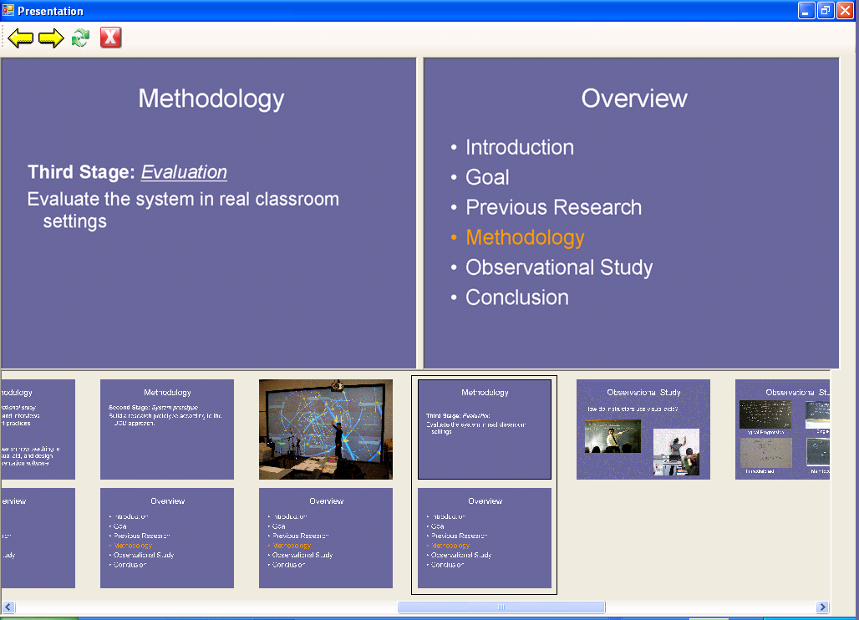
Figure 10. Multipresenter's presenter view in custom mode.

The following guidelines are given for designers of presentation systems:
- Short-term persistency. Data usually builds on top of other data. Showing the latest data longer is beneficial to the audience.
- Long-term persistency. Some data is important throughout longer periods of the presentation. It is important to provide the instructor with a means of showing specific data for longer.
- Pacing. Gradual build-up of the problem is important for learning complex ideas. A presentation system should support temporal build up of rich content.
- Content type. Designers should emphasize support for presenting rich content information, allowing for long-term persistency and easy gesturing. Support content type can be more peripheral.
- Gestures. Gesturing is important to connect the visual aid with the presenters' auditory explanations. A presentation tool should support specific gesturing at areas of the visual presentation. This will be especially important in high-resolution, wall-size displays.
- Dynamicity. Presenters should be allowed to dynamically add, control, change, and remove content.

Limitations:
In the classroom board corpus, most of the courses were science and engineering lectures. This was not by chance: math related courses usually use boards for visual support because of their advantages in problem solving. This does not necessarily generalize to more humanistic areas like psychology or commerce. Also, we only viewed whiteboard usage in classrooms. We have to be careful when generalizing our conclusions to other visual aids.

MultiPresenter
< image of system in use in classroom>

MultiPresenter is an early prototype slide presentation system that is designed to work on multiple displays. From our findings and design guidelines in the observational study we have devised requirements for a system that would use multiple projectors to address some of the limitations of regular presentation software. MultiPresenter allows the presenter to author presentations for two projectors, and control the presentation flow using their laptops. Following our guidelines of short-term persistency, long-term persistency, and dynamicity, it allows the presenter to show previous content (either automatically or user-controlled), to compare between two slides, to have an important slide persist for a long time, or to interactively manipulate content from one screen to the other.
We wanted the system to be simple and usable. Unlike other systems that use multiple projectors using dedicated servers or a complicated infrastructure [refs], we believe that for the system to be usable, it should be lightweight and be able to run on any laptop connecting to existing projectors in any room. To use our system, the only requirement is for the computer used for the presentation to have two (or more) video cards to control the two screens. To achieve this, we used the Village Tronic VTBook© card [ref] that connects to a laptop's PCMCIA slot and adds a graphic card to the laptop.

System Description
MultiPresenter does not allow for authoring of slide content. Slides can be authored by any authoring tool such as Microsoft's PowerPoint and saved in any type of image format. The slides are then loaded to the system as images and are presented in an authoring view in which a stream of slides is shown. When presenting, the system changes to a presentation view (Figure 10) which shows the current two slides on display, and enables the presenter to navigate to different areas in the presentation.
The system has three basic modes. The first two modes assume that the instructor does not want to interact with the system during the lecture. When presenting, the instructor needs to focus on the material presented and it is imperative that the system not add any cognitive load during the presentation. In the first mode, the instructor simply progresses from one slide to the next, as he or she would in a PowerPoint presentation. The system shows the current slide on one screen and may show one, two or four previous slides on the second screen. This way, the audience has the context of previous slides. As we have shown, many referrals back to previous information are to recently shown information, and showing the previous four slides can give the audience the necessary context, and allow the audience to look at previous content they have missed.
The second mode is a pre-made presentation using two screens. Using the system, the presenter can easily build a custom presentation in which he or she indicates which slides will be on which screen. In authoring mode, there are two columns of slots in which slides can fit, representing the two screens. The slide deck loads on a single column, and the user can author a dual-screen presentation by copying, moving or stretching any slide to one or more locations on the second column. When running the presentation, it will show as specified in the authoring mode. This mode can be useful when comparing two slides (e.g. an art class comparing two paintings), when showing an overview slide and a detail slide (e.g. having an overview of the presentation always visible), or when an important slide should be kept for a longer time alongside the regular slides (e.g. the table of elements slide in a chemistry class).
The third mode requires the interaction of the presenter, but as such allows the presentation to be more dynamic and interactive. As in the first mode, the system shows the main stream of slides on one screen. The instructor can at anytime select a part of the slide (e.g., an important diagram) and drag and drop it to the other screen. He or she can then move, resize or erase any snippet on the other screen. All interactions are shown on the presenter's laptop as well as to the audience to keep the audience aware of where the data have come from. This way, the presenter can create and manipulate a "clipboard" of highly referred content items that he or she deems important to keep persistent.

Further work
MultiPresenter is at a very early stage of development, and will require many changes and additions. The most important next step will be to evaluate the systems in use. Although further design iterations are required in the short-term, our long-term evaluation goal is to have instructors at our university use MultiPresenter as an integral part of their classes. We plan to evaluate how they use the system, their response to it, the audience's response, and the audience's learning outcomes.
Electronic ink adds another level of dynamicity and allows the student to follow the presenters' way of thought [ref]. We intend to add the ability to annotate on slides for tablet PC users. This can also be used when one screen will show the slides, while the other is used as a blank writing area like we have seen when instructors used slides and boards together. Following the gesture guideline we intend to add gesture support using electronic ink by having an ink trace that disappears after a few seconds. Other future work includes supporting the pacing guideline, adding support for more than two screens, and integrating the system to run as a plug-in with PowerPoint.

Conclusions
We presented an observational study that looks at the usage of different visual aids in classroom and conference settings. Through this study we have identified some important themes such as similar trends of usage using slides in different settings, the importance of persistency of recent and old data, and differences in rich and support types of data. We devised some design guidelines for designing presentation systems on high-resolution and multiple displays and using these guidelines, we designed an initial prototype presentation system for multiple displays.

REFERENCES
- Anderson, R. J., Hoyer, C., Wolfman, S., and Anderson, R. A Study of Digital Ink in Lecture Presentation. In Proceedings of CHI 2004 (Vienna, Austria), April 24-29, 2004.
- Chiu P, Liu O, Boreczky J, Foote J, Fuse T, Kimber D, Lertsithichai S, Liao C. Manipulating and Annotating Slides in a Multi-Display Environment. Proc. of INTERACT ’03, pp. 583-590.
- Daniels, L. (1999). Introducing technology in the classroom: PowerPoint as a first step. Journal of Computing in Higher Education, 10, 2, 42-56
- Friedland, G., Knipping, L., Schulte, J., Tapia, E. (2004): E-Chalk: A lecture recording system using the chalkboard metaphor. Interactive Technology and Smart Education (ITSE) 1 9–20
- Glover, D.; Miller, D.; Averis, D.; Door, V. (2005) The Interactive Whiteboard: a literature survey. Technology, Pedagogy and Education Volume 14 Number 2, Pp. 106-113.
- Good, L., Bederson, B. Zoomable User Interfaces as a Medium for Slide Show Presentations. Information Visualization 1 (1) 2002, Palgrave Macmillan, pp. 35-49.
- D. Holman, P. Stojadinovi´c, T. Karrer, and J. Borchers. Fly: an organic presentation tool. In Extended Abstracts of the CHI 2006 Conference on Human Factors in Computing Systems, pages 863–868, Montr´eal, Canada, April 2006. ACM Press.
- Kam, M., J. Wang, A. Iles, E. Tse, J. Chiu, D. Glaser, O. Tarshish, and J. Canny. Livenotes: A System for Cooperative and Augmented Note-Taking in Lectures. CHI: ACM Conference on Human Factors in Computing Systems. pp. 531–40, 2005.
- Kaiser E., Barthelmess P, Erdmann C, Cohen P. (2007) Multimodal Redundancy Across Handwriting and Speech During Computer Mediated Human-Human Interactions. Proceedings of SIGCHI conference on Human factors in computing systems. pp 1009-1018.
- Kjeldsen J., The Rhetoric of PowerPoint. Seminar.net - Media, Technology and liftelong learning Vol.3, Issue 1, 2007
- Lanir, J. & Booth, K. (2007). Understanding Instructors' use of visual aids in classroom setting. In Proceedings of World Conference on Educational Multimedia, Hypermedia and Telecommunications 2007 (pp. 788-794). Chesapeake, VA: AACE
- Levasseur D. G., Sawyer K. J. (2006). Pedagogy meets PowerPoint: A research review of the effects of computer-generated slides in the classroom. The Review of Communication Vol 6, no. 1-2 pp. 101-123
- Meyer, Richard E., (2003). Multimedia Learning. Cambridge University Press. Cambridge.
- Microsoft PowerPoint. 2007. http://www.microsoft.com/ /powerpoint
- MIT Open Courseware. http://ocw.mit.edu/OcwWeb/ index.htm
- Myers, B. Using handhelds and PCs together. CACM, 44:11, 2001, pp. 34–41.
- Mynatt, E., Igarashi, T., Edwards, W.K. and LaMarca, A. (1999) Flatland: New Dimensions in Office Whiteboards. In Proc. CHI '99, pp. 346-353.
- Nelson, L., S. Ichimura, E. R. Pedersen, and L. Adams. Palette: A Paper Interface for Giving Presentations. CHI: ACM Conference on Human Factors in Computing Systems. pp. 354–61, 1999.
- Norman D, (2004) In Defense of PowerPoint. . http://www.jnd.org/dn.mss/in_defense_of_p.html
- Parker I, (2001). Absolute PowerPoint. The New Yorker, 77 (13), 76-87
- Pederson, E., McCall K, Moran T, Halasz F. ‘Tivoli: An Electronic Whiteboard for Informal Workgroup Meetings:’ in Proceedings INTERCHI'93: Human Factors in Computing Systems. 1993. Amsterdam, The Netherlands pp. 391-398.
- Rekimoto, J. (1998) A multiple device approach for supporting whiteboard-based interactions. Proceedings of SIGCHI conference on Human factors in computing systems. pp 344-351
- Röüling G, Trompler C, Mühlhäuser M , Köbler S , Wolf S, (2004) Enhancing classroom lectures with digital sliding blackboards, Proceedings of the 9th annual SIGCSE conference on Innovation and technology in computer science education, Leeds, United Kingdom
- Smith, H.; Higgins, S.; Wall, K.; Miller, J. (2005) Interactive whiteboards: boon or bandwagon? A critical review of the literature. Journal of Computer Assisted Learning 2005 21:2 Pp. 91-101.
- Sweller, J., Cognitive load during problem solving: Effects on learning, Cognitive Science, 12, 257-285 (1988).
- Szabo, A., & Hastings, J. (2000). Using IT in the undergraduate classroom: Should we replace the blackboard with PowerPoint? Computers and Education, 35, 175-187
- Tufte Edward (2003). The Cognitive Style of PowerPoint. Graphics Press, Cheshire, CT

